**CARNEGIE MELLON UNIVERSITY**

**Advanced Mobile Application Development**

**Project name:** Mentale

**Iteration 1: Speculate plan**

**Done by:**

Jean Sauveur Mizerere Rukundo

Orly Mugwaneza

Sabin Sheja

1. **Features:**

## 1.1. Patient side:

* User registration and login
* Providing daily mood by answering a set of questions
* Receiving results and suggestions from the diagnosis
* Booking a nurse/doctor
* Chatting with a nurse through video call

## 1.2. Practitioner side

* User registration and login
* Receive pending appointment requests
* Get confirmed appointments
* Set availability
* Chatting with a patient through video call

# **Plan for iteration 1**

|  |  |  |  |  |  |
| --- | --- | --- | --- | --- | --- |
| **User type** | **Feature** | **Details** | **Priority** | **Start time** | **End time** |
| Patient | Registration | * Phone number verification * Get user information and save in database | High | 01/31/2020 | 02/01/2020 |
| Login | * Provide a way to log out * User provide credentials * Authentication | High | 01/31/2020 | 01/31/2020 |
| Booking | * Choose appointment type(in person or video chat) * Choose region * Choose date * Choose available practitioner | High | 02/03/2020 | 02/16/2020 |
| Receive notification one hour before appointment time | * A push notification is sent to the patient one hour before appointment time | Medium |  |  |
| Identify questions for mood of the day | * Identify starter questions for depression and drugs * Identify questions for mood of the day |  | Already started | 02/17/2020 |
| Practitioner | Registration | * Phone number verification * Get user information and save in database | High | 01/31/2020 | 02/02/2020 |
| Login | * Provide a way to log out * User provide credentials * Authentication | High | 01/31/2020 | 02/02/2020 |
| Set availability | * Set availability on a calendar | High | 02/03/2020 | 02/07/2020 |
| Display confirmed appointments | * Show confirmed appointment on a calendar with patients’ names | High | 02/08/2020 | 02/16/2020 |
|  | Receive notification one hour before appointment time | * A push notification is sent to the practitioner one hour before appointment time | Medium |  |  |

# Plan for iteration 2

## 3.1. Patient side:

* Providing daily mood by answering a set of questions
* Receiving results and suggestions from the diagnosis
* Chatting with a nurse through video call

## 3.2. Practitioner side:

* Chatting with a patient through video call

# 

# **Prototype**

## 4.1. Registration

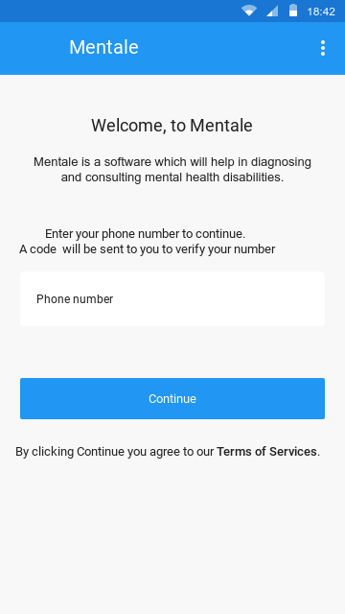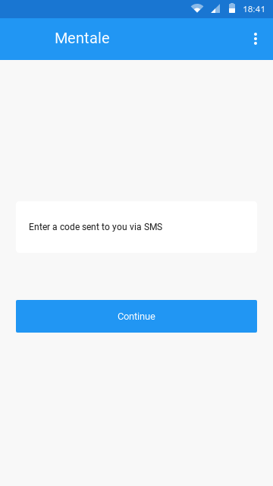

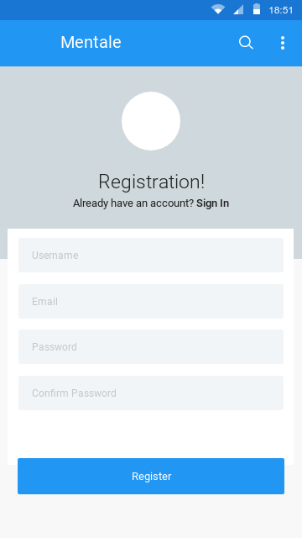

## 4.2. Login

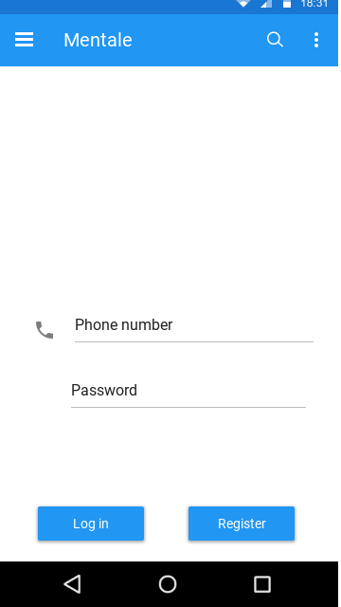

## 4.3. Booking Appointment

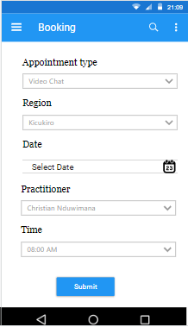

## 4.4. Set Availability

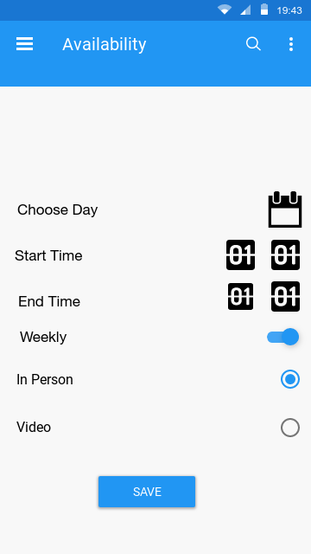

## 4.5. Display Appointments

